Project Design Phase-II
Data Flow Diagram & User Stories

Date | 27 june 2025
Team ID | LTVIP2025TMID31752
Project Name | Sustainable Smart City Assistant
Maximum Mark | 4 Marks

Data Flow Diagrams:
A sustainable smart city assistant connects people, data, and technology to promote greener, more efficient living. It gathers information from citizens, sensors, and policies—analyzes it—and delivers useful insights, eco-friendly tips, and city services in real time. Simple, smart, and sustainably aligned.
  - User interactions are managed through a conversational interface. Real-time data from sensors and APIs is aggregated and cleaned.
  - Analytics predict resource usage and detect anomalies.
  - Policy documents are summarized into digestible insights.
  - Recommendations are generated for citizens and planners.

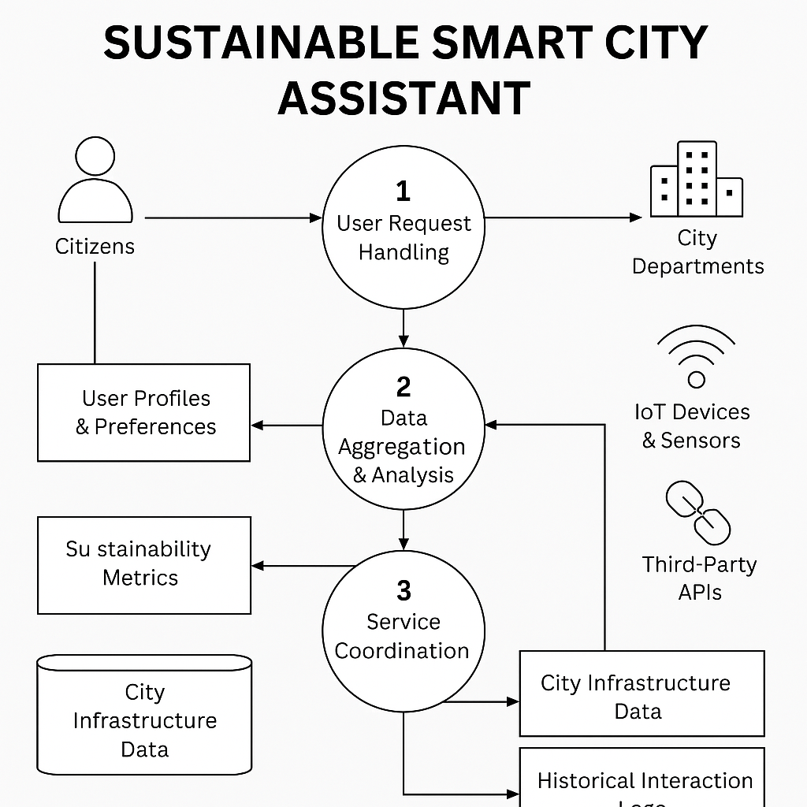

User Stories
user stories for a Sustainable Smart City Assistant:
- Citizens want helpful, everyday tools—like eco-tips, real-time transit updates, and issue-reporting features—to make more sustainable choices and stay engaged with their city.
- City Officials need data-driven insights and summarized feedback to shape responsive policies and prioritize citizen needs effectively.
- System Administrators focus on system reliability and continuous improvement through monitoring and testing of AI models and sensor data.

User Type | Functional Requirement (Epic) | User Story Number | User Story / Task | Acceptance criteria | Priority | Release
citizen | Registration | USN-1 | As a resident, I want personalized eco-tips based on my habits | citizens believe the assistant improves their daily life or decision-making. | High | Sprint-1
 |  | USN-2 | As a commuter, I want real-time transport and traffic updates | The system is intuitive and accessible to users of all digital skill levels. | High | Sprint-1
 |  | USN-3 | As a concerned citizen, I want to report issues like leaks or dumping | Citizens feel their data is secure and the assistant is reliable. | Low | Sprint-2
 |  | USN-4 | As a user, I can register for the application through Gmail |  | Medium | Sprint-1
 | Login | USN-5 | As a user, I can log into the application by entering email & password |  | High | Sprint-1
 | Dashboard
city officer |  |  | Supports local, state, and national sustainability goals and urban development plans.
Customer Care Executive |  |  | Provides actionable insights from real-time and historical data to inform planning.
Administrator

